1. **Deep learning v/s machine learning**

Machine Learning: - It finds the relationship between Input and Output by statistcal measure

Deep learning: - It finds the relationship between Input and Output by Logical Neural Network (brain)

**Types**

**1.1 Data Dependency**

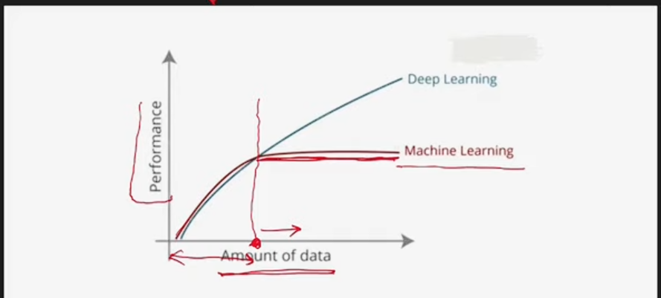

* If less data machine learning performs better
* If more data Deep learning performs better

**1.2 Hardware Dependency**

* Low hardware is enough for ML (CPU)
* High Hardware is needed for DL (GPU)

**1.3 Training Time**

* DL need more time for training data -> ex week, month’s
* ML need less time for training data -> ex minuts, hours

**1.4 Feature Selection**

* In ML we manually have to give feature(columns) for training
* In DL it automatically creates its own feature by using the concept called Representation
  1. **Interpretability**
* **We can know whats happening behind scene in ML**
* **We cannot know whats happening behind scene in DL**

1. **Why Now too Trending**

Started in 1960’s but famous in 2012 why ? below image is explaination

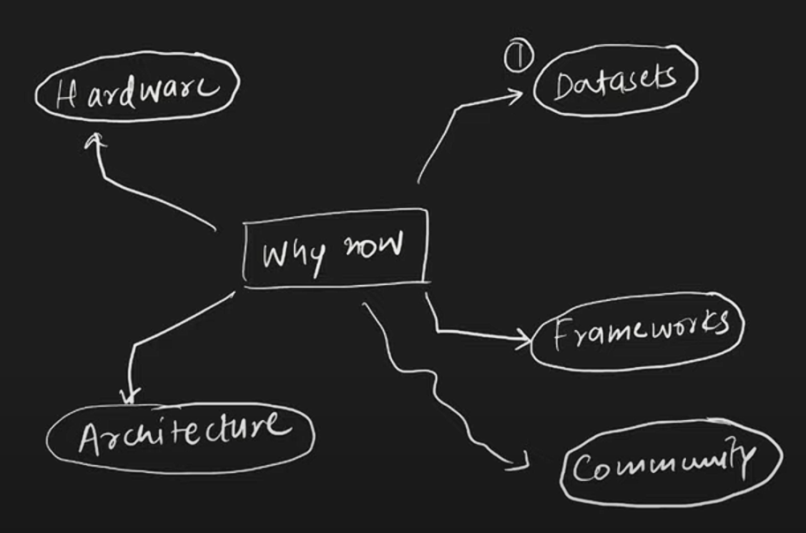

**2.1 Dataset**

DL it needs more data for more accuracy and from 2010 – 2022 the data are growing at 4x rate so it’s really suits for deep learning

**2.2 Hardware**

Some one found that matrix problem can be solved in parallel way so that same method applied for deep learning solution by using GPU it was 10-20 time faster so from that hardware was also a part for deep learning to solve the problem much faster

**2.3 Frameworks/Libraries**

In ML we have scikit-learn libraries to use model for ML but for DL we didn’t had any to use at that time google introduced tensorflow libraries and facebook introduced pytorch libraries

* Tensorflow was so difficult that writing the code was much difficult so keras was developed on top of the tensorflow now its much easier

**2.4 Architecture**

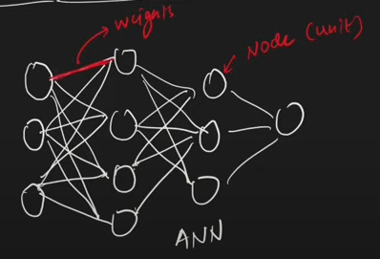

We can build different variation of Node[Perceptron] and weights and build the architecture but it would be time , money , effort consuming so data scienctiest have already build these architecture we just have import and use it.

**2.5 People/ Community**

